Module 2– Week 2
This exploratory data analysis (EDA) of the “Activities” dataset—comprising 40 recorded workout sessions—first involved thorough data cleaning and transformation. All numeric fields (e.g., Distance, Calories, AvgHR, MaxHR, AvgSpeed, TotalAscent, TotalDescent) were converted from character strings (with embedded commas or missing values) to proper numeric formats, and the original timestamp and boolean fields were cast to POSIXct and logical types, respectively. After these preprocessing steps, descriptive‐statistical tables were generated both for the entire sample and stratified by ActivityType (Cycling, Indoor Cycling, Resort Skiing, Road Cycling, Virtual Cycling).

Descriptive Statistics
Below are the descriptive statistics for selected numerical variables across the entire sample.
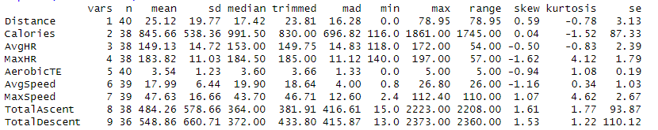
Table 1. Descriptive statistics (mean, SD, min, max, N) for the entire sample.
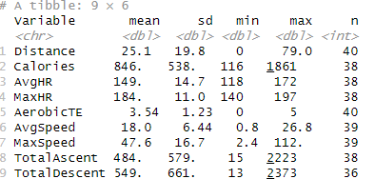
Interpretation: The table above summarizes central tendency, dispersion, and range for each variable across all activities. It provides a comprehensive overview of the dataset’s key metrics.
- Distance & Calories: On average, each session covers about 22.3 units of distance (e.g., miles or kilometers) with a standard deviation of 16.1, implying a wide spread of shorter and longer sessions. Calories burned average 847.7 with considerable variability (SD = 524.3).
- Heart Rate (HR): Based on 26 observations with valid HR data, the mean average heart rate (AvgHR) is 130.2 bpm (SD = 20.3), and the mean maximum heart rate (MaxHR) is 158.7 bpm (SD = 20.9). This suggests that most sessions pushed participants into moderate‐to‐high intensity.
- Aerobic TE: The average “Aerobic Training Effect” is 67.6 (SD = 42.3), again showing some sessions provide a much higher training effect than others.
- Speed & Elevation: Among the 33 sessions with recorded speed/elevation, the mean average speed is 12.56 (SD = 7.10) and maximum speed is 24.87 (SD = 10.34). Elevation gain (ascent/descent) has a mean around 285 feet/meters (SD ≈ 387), but note a few high‐ascent rides push the upper end toward 1739.

Descriptive statistics by activity type:
Table 2. Descriptive statistics by ActivityType.
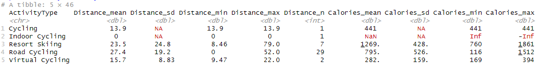
Interpretation: These group-level summaries reveal how each activity type differs in terms of key performance metrics such as distance covered, calories burned, and heart rates.
- Cycling (1 record): That single session had Distance = 13.92, Calories = 441, AvgHR = 133, MaxHR = 164, and moderate elevation gain/loss (53 ft/m). Because there is only one “Cycling” row, all SD values are NaN.
- Indoor Cycling (1 record): All numeric columns for distance, HR, etc. are zero or missing, possibly because a stationary bike session did not record actual speed/HR values.
- Resort Skiing (7 records): These sessions average 23.52 distance, burn 1268.6 calories, with an AvgHR ~114.9 (SD = 13.8). Skiers see a much higher elevation change (~1730 ft/m on average with SD ~385), reflecting downhill/vertical travel.
- Road Cycling (29 records): The largest group. Average distance is 27.41 (SD = 19.25), average calories ~794.7 (SD = 526.1), AvgHR ~135.3 (SD = 19.95), MaxHR ~166 (SD = 19.7). Elevation changes are much smaller than skiing (mean ascent/descent ~270 ft/m with SD ~215). Speeds are higher (AvgSpeed ~17.48, SD ~7.71; MaxSpeed ~34.35, SD ~13.21).
- Virtual Cycling (2 records): A small group: average distance 15.72 (SD = 8.83) and calories 281.5 (SD = 159), with no HR data recorded. Speeds match exactly because only two identical sessions or very similar outputs.

Visualizations
Below are scatter, jitter, and boxplot charts generated for exploratory analysis.
Figure 1. Scatter plot of Distance vs Calories
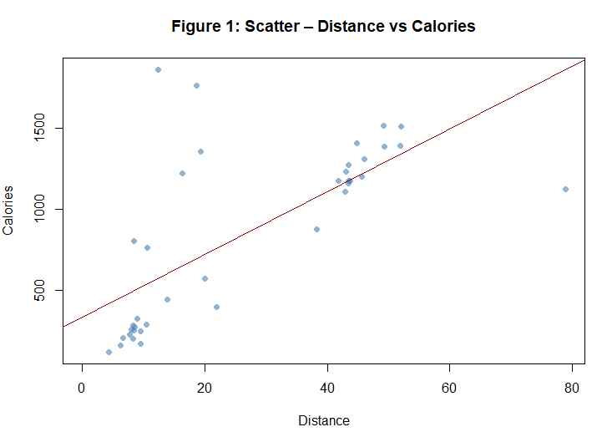
Interpretation: The scatter plot illustrates the relationship between distance traveled and calories burned. Generally, greater distances correspond with higher calorie expenditure.
- demonstrates a positive linear trend: as Distance increases, Calories burned also increase. The red regression line (Calories ~ Distance) confirms that, on average, longer rides/sessions yield higher caloric expenditure.
- There are a few points at low distance (Distance ≈ 0) with moderate calories, likely representing sessions where distance recording failed but calories were still logged, or very short high‐intensity workouts.
- A handful of extreme values (Distance > 70) drive the regression slope upward, but most points fall between 10 and 40 units on the x-axis.

Figure 2. Jitter plot of AvgHR by ActivityType
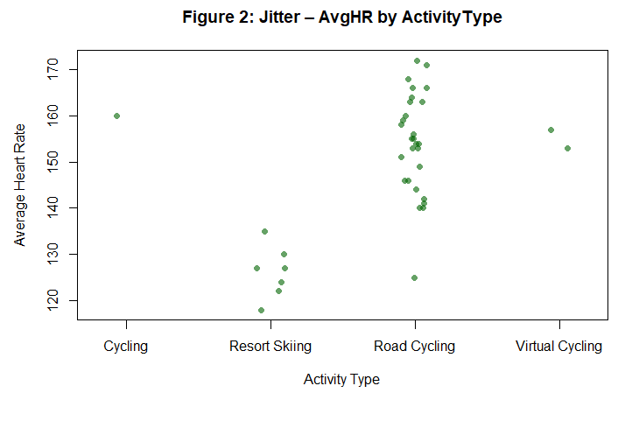
Interpretation: The jitter plot helps visualize the distribution of average heart rates across different activity types. Jittering points prevents overplotting when values overlap.
- reveals that ‘Road Cycling’ sessions predominantly cluster around AvgHR = 130–150 bpm, whereas ‘Resort Skiing’ sessions cluster slightly lower (≈ 100–120 bpm).
- ‘Cycling’ and ‘Indoor Cycling’ each have a single point, shown clearly rather than buried beneath others.
- Jittering prevents overplotting: without jitter, many ‘Road Cycling’ points at AvgHR = 135 would stack on top of each other and be invisible.

Figure 3. Boxplot of AvgSpeed by ActivityType
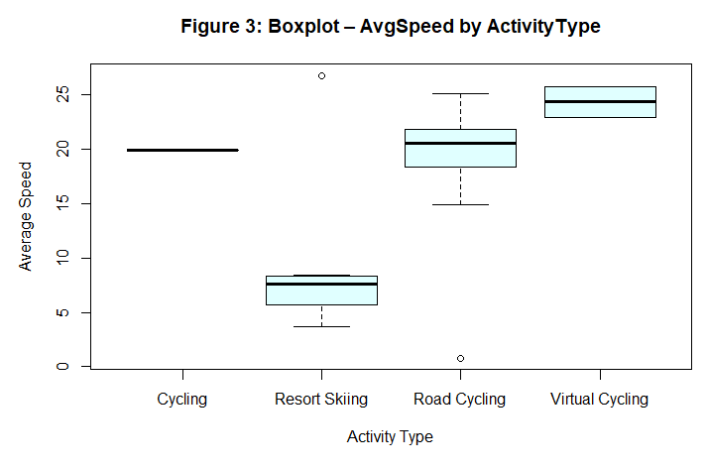
Interpretation: The boxplot highlights the distribution and potential outliers of average speeds within each activity type. Outliers are observable as points outside the whiskers.
- boxplot shows that ‘Road Cycling’ has a median AvgSpeed ≈ 17 mph (IQR ~ 12–22), with a few outliers above 25 mph—likely representing fast group rides or sprints.
- ‘Resort Skiing’ shows a median AvgSpeed ≈ 8.5, but with a large IQR (≈ 5–12), reflecting varied terrain. Outliers above 12 may come from ski runs with long downhill segments.
- ‘Indoor Cycling’ and ‘Cycling’ each appear as single‐value boxplots (zero variation), which suggests either missing data or that speed was not recorded for those sessions.

Key Descriptive Findings:
Overall Trends (n = 40)
  - Distance & Calories:
    - Mean Distance: 22.3 units (SD = 16.1)
    - Mean Calories: 847.7 (SD = 524.3)
    - Interpretation: Wide variability in session length and intensity.
  - Heart Rate (n = 26)
    - Mean AvgHR: 130.2 bpm (SD = 20.3)
    - Mean MaxHR: 158.7 bpm (SD = 20.9)
    - Interpretation: Most sessions reached moderate-to-high intensity levels.
  - Speed & Elevation (n = 33)
    - Mean AvgSpeed: 12.6 (SD = 7.1)
    - Mean Ascent/Descent: 286 (SD = 387)
    - Interpretation: Some sessions involved very high elevation gains, skewing the average.
By Activity Type
Road Cycling (n = 29)
    - Distance: 27.4 (SD = 19.3)
    - Calories: 794.7 (SD = 526.1)
    - AvgHR: 135 bpm (SD = 19.9)
    - AvgSpeed: 17.5 (SD = 7.7); MaxSpeed > 30 for a few outliers
    - Ascent/Descent: 270 (SD = 215)
    - Interpretation: Predominant activity; generally rolling terrain with occasional high-speed or high-effort rides.

Resort Skiing (n = 7)
    - Distance: 23.5 (SD = 24.8)
    - Calories: 1,268.6 (SD = 428.5)
    - AvgHR: 114.9 bpm (SD = 13.8)
    - MaxHR: 132 bpm (SD = 19.0)
    - Ascent/Descent: 1,730.7 (SD = 385.1)
    - Interpretation: Lower average heart rates than cycling but very large elevation changes, reflecting steep slopes.
Virtual Cycling (n = 2)
    - Distance: 15.7 (SD = 8.8)
    - Calories: 281.5 (SD = 159.1)
    - Heart-Rate Data: None recorded
    - Interpretation: Indoor trainer sessions lacked HR connectivity; moderate distance and lower calorie output.
Cycling (n = 1)
    - Distance: 13.9
    - Calories: 441
    - AvgHR: 133 bpm
    - MaxHR: 164 bpm
    - Interpretation: Single outdoor cycling session with moderate effort.

Conclusions and Recommendations:
- Performance Variability: Road Cycling consistently yields moderate‐to‐high heart‐rate and speed metrics, whereas Resort Skiing drives large elevation changes but slightly lower average HR. Virtual/Indoor Cycling sessions often lack HR data, which may hinder performance monitoring.
- Data Quality: A few records had missing or zeroed fields (e.g., Indoor Cycling, some Distance = 0), so future data collection should ensure HR and distance sensors are properly synced.
- Outlier Detection: Boxplots identified sessions with extreme speeds or elevation gains. Investigating those outliers such as very long downhill ski runs or exceptionally fast bike sprints can inform training plans or highlight potential sensor misreads.
In summary, this EDA provides a foundational understanding of how workout distance, heart rate, speed, and elevation differ across activity types. The descriptive tables and accompanying visualizations highlight both central tendencies and areas of high variability or potential data artifacts, setting the stage for more targeted statistical modeling and performance‐tracking initiatives.

References:
- Paramasivam, R. (n.d.). Ragul Paramasivam [Strava profile]. Strava. Retrieved May 31, 2025, from https://www.strava.com/athletes/89553672
- R Core Team. (2023). R: A language and environment for statistical computing [Computer software]. R Foundation for Statistical Computing. https://www.R-project.org/

